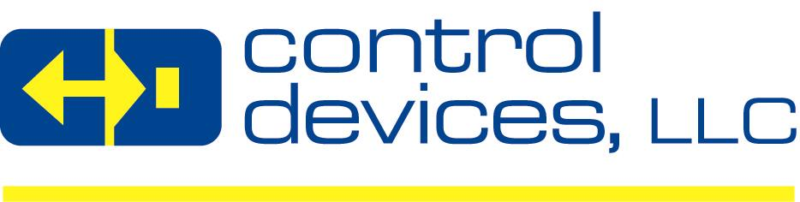
POSITION TITLE: | Maintenance Technician – 2nd Shift
COMPANY: | Control Devices LLC
DEPARTMENT/LOCATION | Maintenance; Fenton, MO
REPORTS TO: | Facilities & Maintenance Manager
POSITION SUMMARY: | Maintenance Technician with experience with Pneumatics, Hydraulics and CNC electrical, plumbing and electrical machine wiring. Machining and Fabrication experience helpful but not required. General maintenance experience.
COMPANY BACKGROUND: | Control Devices, LLC (“Control Devices” or “CD”) is a leading designer & manufacturer of high quality flow control valves, condensate removal traps, related components & accessories serving the compressed air, pressure washer, vehicle systems, fire protection, specialty gas, & the industrial, agricultural & food service float valve markets. CD prides itself in the ability to design, innovate & manufacture flow control valves for custom applications & offers a line of standard products that has grown over the years. CD is based in Saint Louis, MO & its products are sold on a global basis to O.E.M’s, Distributors & End Users.  Control Devices is a privately owned company with a very seasoned management team focused on organic sales growth with existing products & new revenue growth through acquisitions.

QUALIFICATIONS: | REQUIREMENTS:
REQUIRED SKILLS: | - CNC electrical experience preferred .General working knowledge of Pneumatic, Hydraulics, plumbing and electrical machine wiring.
DESIRED SKILLS: | - Machining & Fabrication experience helpful, but not required.

