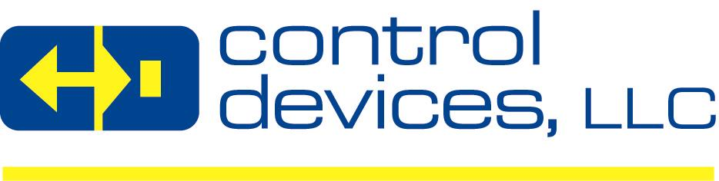

POSITION TITLE: | Pack/Wash – Machine Shop
COMPANY: | Control Devices LLC
DEPARTMENT/LOCATION | Machine Shop
REPORTS TO: | Machine Shop Supervisor
POSITION SUMMARY: | This position is responsible to inspect, wash, pack, label and box various machine shop parts. Will inspect and wash parts in appropriate solution. Requirements include but are not limited to: Must be safety and quality conscious, be able to lift up to 35 pounds. PPE such as safety glasses, hearing protection, and safety shoes are required at all times. Due to possibly sharp parts, finger wrapping is suggested. Due to washing solution a mask and gloves are also suggested.
COMPANY BACKGROUND: | Control Devices, LLC (“Control Devices” or “CD”) is a leading designer and manufacturer of high quality flow control valves, condensate removal traps, related components and accessories serving the compressed air, pressure washer, vehicle systems, fire protection, specialty gas, and the industrial, agricultural and food service float valve markets. CD prides itself in the ability to design, innovate and manufacture flow control valves for custom applications and offers a line of standard products that has grown over the years. CD is based in Saint Louis, MO and its products are sold on a global basis to O.E.M’s, Distributors and End Users.  Control Devices is a privately owned company with a very seasoned management team focused on organic sales growth with existing products and new revenue growth through acquisitions.
KEY RESULT AREAS: | RESPONSIBILITIES:
- Maintains safe and clean working environment by complying with procedures, rules, and regulations.
- Documents actions by completing production and quality forms.
- Contributes to team effort by accomplishing related results as needed.

QUALIFICATIONS: | REQUIREMENTS:
REQUIRED EDUCATION: | - High School Diploma/GED Equivalent  - Basic Math
REQUIRED EXPERIENCE: | - Entry Level
REQUIRED SKILLS: | - Attention to detail  - Excellent vision  - Good eye hand coordination  - Good dexterity  - Quality focused  - Safety focused  - Ability to use testing equipment  - Ability to work in a hot and oily environment
DESIRED SKILLS: | - Ability to lift up to 35lbs
CONTACT: | Internal applicants please submit internal applications to HR. If posted externally, external candidates can apply at www.cdivalve.com, click Careers tab

Revised 06/14/2019

