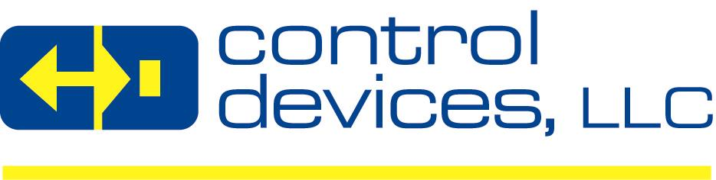

POSITION TITLE: | Hydromat Machinist
DEPARTMENT: | Machine Shop
REPORTS TO: | Machine Shop Supervisor
SHIFT(S): | 3rd Shift
EMPLOYEES SUPERVISED: | Hydromat Operators, Hydromat Attendants
PROGRESSION LEVEL: | 7+
FLSA STATUS: | Non-Exempt
POSITION SUMMARY/PRIMARY FUNCTION: | This position is responsible for the set up and operation of a wide range of jobs assigned to Hydromat rotary transfer machines while following the documented procedures, including safety procedures. Will be responsible for the quality of parts produced. Assists in the instruction of set-up, operators, and operator trainees. Diagnose, troubleshoot and make adjustments. May be assigned to remove and/or replace worn or defective parts. Must have the fundamental tools to safely and effectively perform the job.
DUTIES AND RESPONSIBLITIES: | - Must be able to set up, operate and adjust Hydromat rotatory transfer machines  - Responsible for operating the machines, tool monitoring and replacement, stocking and loading the machine, keeping it filled with proper oil levels, cutting fluids or lube and keep the machine free of chip build-up  - Required to make all tool adjustments, offsets and troubleshoot problems; set speeds, and feeds for proper materials and do minor repairs as needed  - Meet the production rates set for each machine  - Check and monitor parts to ensure they remain within the part specifications. Perform all necessary quality checks using precision measuring instruments  - Communicate daily with supervision, other operators, and personnel to make sure that the operation/job is completed correctly  - Keep accurate counts and production records  - Requires the use of precision measuring devices  - Responsible for the quality of parts produced  - Assists in the instruction of Set-Up Trainees, Operators, and Operator Trainees  - Maintain a clean and safe working environment at all times  - Other duties as assigned
QUALIFICATIONS
REQUIRED EDUCATION: | - High School Diploma or Equivalent
REQUIRED EXPERIENCE: | - 3-5 years setting up and operating Hydromat rotary transfer machines in a manufacturing environment preferred
REQUIRED SKILLS AND COMPETENCIES: | - Excellent blue print reading skills  - Strong math skills and ability to read blueprints, work instructions, SOP’s, and other technical information in English.  - Must be able to lift 35lbs. on a regular basis  - Must be able to use tools, equipment, work aids, and precision measuring instruments  - Must be able to monitor gauges, dials, and other indicators to be sure the machine is working properly and use proper precision measuring devices  - Attention to detail and ability to handle multiple priorities  - Must be self-directed and take initiative to learn new skills relating to the maintenance of the machine  - Ability to learn new technical skills  - Ability to use precision measuring devices  - Ability to work individually and as part of a team  - Ability to work in an oily and noisy environment  - Ability to sit, stand, reach, pull, bend, and lift throughout the entire shift  - Ability to perform physical labor  - Ability to be certified on a forklift, overhead crane, high pressure gas, and Lock Out Tag Out
WORKING CONDITIONS: | Work is performed in a plant environment with a significant amount of walking on oily concrete surfaces. Work conditions during the summer months can be very hot, and during the winter months very cold. Workspaces can be very dusty, oily and noisy due to operating machines and traffic of motorized vehicles in the facility. Employees are required to wear the appropriate Personal Protective Equipment (earplugs, safety glasses, and steel-toed shoes) at all times. Employees may be exposed to sharp objects due to moving the chips and working with damaged product.
CONTACT: | Apply at www.cdivalve.com, click Careers tab
Revision Date: 08/01/2019 APPROVED BY:

This job description does not list all the duties of the job. Performance of other duties may be requested. Control Devices has the right to revise this job description at any time. The job description is not a contract for employment.

EXERNAL JOB POSTING INFORMATION

COMPANY INFORMATION: (RECRUITING PURPOSES)
Control Devices, LLC (“Control Devices” or “CD”) is a leading designer & manufacturer of high quality flow control valves, condensate removal traps, related components & accessories serving the compressed air, pressure washer, vehicle systems, fire protection, specialty gas, & the industrial, agricultural & food service float valve markets. CD prides itself in the ability to design, innovate & manufacture flow control valves for custom applications & offers a line of standard products that has grown over the years. CD is based in Saint Louis, MO & its products are sold on a global basis to O.E.M’s, Distributors & End Users.

CD is a privately owned company with a seasoned management team focused on organic sales growth with existing products & new revenue growth through acquisitions.

CD offers competitive compensation, a comprehensive benefits package, paid time-off, steeled-toed shoes reimbursement, casual dress work environment and solid 401K retirement plan to promote financial security.
CD is an equal opportunity employer. All applicants will be considered for employment without attention to race, color, religion, sex, sexual orientation, gender identity, national origin, and veteran or disability status.

